GUIDELINES FOR TECHNOLOGY TRANSFER PROJECT PROPOSAL
(Submit 4 hard copies along with a soft copy)

1. Title: Title should be brief, accurate and self explanatory.

2. Applicant’s Details: (a, b and c at Sr. No. 2) Principal Investigator with the help of Co-Principal Investigator will be responsible for implementation and will participate in it. In addition to the Principal Investigator, a list of professional, technical and other personnel to be engaged in the project along with their qualifications, experience and duties should be given. The Bio-data of Principal Investigator and Co-Investigator should also be annexed with the proposal to judge the competence of Investigators. Attach a list of research publications carried out by the PI during the last 5 years. The consent of the Co-PI to carryout project activities may also be attached with the proposal.

The Co-Principal Investigator may be from the discipline of the Principal Investigator or from any other depending upon the nature of proposal.

3. Overseas cooperating Scientists/Organization. Identify an Overseas Scientist/Organization willing to cooperate in the proposal i.e. those which will be directly involved in research in Overseas or those which will provide technical services for which no funds are required from the budget. Also elaborate how the linkages & coordination with cooperating organization will be strengthened.

4. Total Cost: Mention total budget requirement according to the Budget details

5. Location: Give details of Institute/Department and field locations where the work will be done.

6. Duration: Give time (months) required for completion of the proposal.

7. General
Existing Situation: Provide a statement of the problem and significance of the project for sustainable agriculture. Also give a brief statement of prior work that supports the need to do this work and on which the work proposed in this application is based. Please also review the similar work being done elsewhere or already done, particularly in Pakistan and ensure that there is no duplication.
Scope and Issues, and your approach to address them: State the targeted issues and subjects in relevance to the proposed project and the approaches that will be used.
Justification: Give justification of the proposed project explaining how the proposal is important and beneficial to the society. The proposal should be well oriented and well focused for finding a solution to a problem.

8. The Technology
Describe the said technology and its potential to the enhancement of agricultural production in the country.
If tested earlier, give a statement of practical application and results/achievements obtained regarding the use of this technology
9. Objectives: Objectives represent the desired future situation giving solution to the identified problems. The objectives should be specific and in quantitative terms. Please do not give statement like, “it will increase agricultural production in the country.”

10. Methodology: Provide detailed description of the methods to be used. It is valuable to breakup the activities into specific tasks, which can each be assessed and linked to proposed objectives. Give details of the type of data to be collected and analyzed/statistical methods. Also describe the modes of documenting different steps of implementation and achievements of the project i.e., audios, videos, pictorial, demos, questionnaires, interviews, etc. and at what time?

11. Plan/Schedule of Work: State the major activities year-wise, their location and the researcher/scientists responsible.

12. State if the project has been submitted to any other funding agency for financial support. If so with what results?

The investigators often submit their proposals to more than one funding agency. It is therefore, appropriate to provide the information to avoid any complication.

13. Give detail of other projects separately being run by the PI and Co-PI along with the status of the project i.e. its duration (from-to) and responsibility as PI or Co-PI.
This information is required to assess the pre-engagement of the scientists and to ensure their maximum availability to run this project smoothly.

14. Project Cost:
a. Budget summary – self explanatory
b. Budget details – Give head wise detailed budget estimates (the estimates must be justified
as per project activities).

Explanation of some heads is given as under:
Honoraria (A030). The PI and Co-PI shall be entitled to draw remuneration per year as under:

S. # | University Faculty  members | Scientists/experts of other organizations (BPS) | PI | Co-PI
1. | Professor | 21 | Rs. 80000/- | Rs. 40000/-
2. | Associate Professor | 20 | Rs. 70000/- | Rs. 35000/-
3. | Assistant Professor | 19 | Rs. 60000/- | Rs. 30000/-
4. | Lecturer/Research Officer | 17 & 18 | Rs. 50000/- | Rs. 25000/-
Seminar/Workshop/Symposia (A03903): Expenditure incurred on seminar/workshop for scientists to be held at the Host Institution in the last/third year of the project will be met out of this head. This seminar/workshop should focus on results, accomplishments of the technology transfer project and future strategies.
Fellowship/Stipend (A03959): Fellowship/Stipend shall be paid at the following rates:
  - For Ph.D student (completed 18 years education in the relevant field)= Rs.13000/PM
  - For M.Sc(Hons)/M.Phil student (completed 16 years education in the relevant field) = Rs. 8000/PM
Exhibitions, Fairs and Framer days (A03918): Expenditure incurred on dissemination events (i.e Training of farmers/Extension workers, Farmer focus group meetings, Farmers Field days, Demos, Exhibitions, Media events etc.) will be met out of this head.
Service Charges (Audit/Account Fee): Will be worked out as 2% of the operational expenses
Payments to Govt/University for services (Support to Host Institutes): Will be worked out as 15% of operational expenses.

15. Certification: Self explanatory.

16. Endorsement:
- In case of faculty members from UAF, endorsement is required from the Chairman and Dean/Director concerned and the proposal must be routed through Director, ORIC.
- In case of applicants from outside the UAF, endorsement from the Head of Institution/organization required in addition to the concerned Dean/Director/Chairman.

Literature Cited: All the references cited in the text should be enlisted in alphabetical order following “Author-Year-Title-Source” System.

 | ENDOWMENT FUND SECRETARIAT  UNIVERSITY OF AGRICULTURE, FAISALABAD, PAKISTAN  UAF-US COLLABORATION FOR STRENGTHENING OF AGRI. ACADEMIA  Phone: 041-9201125, 9200161-170, Ext. 3604, 3607, Fax: 041-9201333  Email: efs@uaf.edu.pk
Proposal Identification No
(To be allotted by EFS)
COMPLETE PROJECT PROPOSAL
(Technology Transfer)
1. Project Title: _________________________________________________________

2. Applicant's Details:
Note: (Only regular/TTS faculty members/researchers/scientists of all public entities which demonstrate needed research and development capabilities in the relevant field and financial responsibilities may apply).
- Principal Investigator:
Name: _______________________________________________________
Qualification:__________________________________________________
Institution/Organization: _________________________________________
Present Position: _______________________________________________
Status (Regular/TTS/Adhoc/Contract): ________________________________________
Postal Address: ________________________________________________
Telephone: ______________ Mobile: _________ Fax: ___________E-mail: ____________

- Co-Principal Investigator (Information as above):

- Other local team members (if any, information as above):

3. Overseas cooperating Scientist/Organization:
Name: ________________________________________________________
Qualification: ___________________________________________________
Institution/Organization: __________________________________________
Postal Address: _________________________________________________
Telephone: ________________ Fax: ____________E-mail: __________________________

4. Total Cost (Rs. Million): _______________________________________________

5. Project Location: _____________________________________________________

6. Project Duration (months): _________ Date of initiation: ______________

7. GENERAL
What is Existing Situation? What are the scope and issues to be addressed and your approach to address them? Give Justification of the project
8. THE TECHNOLOGY
Give brief overview of the Technology to be transferred
Have you practically tested these methods earlier? If, yes, where and with what results?

9. OBJECTIVES:
10. METHODOLOGY (Describe in detail; see Guidelines)

11. PLAN OF WORK:
Year |  | Activities | Location | Responsibility
1 | 1st half
1 | 2nd half
2 | 1st half
2 | 2nd half
3 | 1st half
3 | 2nd half

12. State if the project has been submitted to any other Funding agency for financial support. If so, with what results?
_____________________________________________________________________

13. No of projects being run by:

a) PI
Project title and  duration (from-to) | Status as  PI or Co-PI | Funding Agency | Budget
1.
2.
3.

b) Co-PI
Project title and  duration (from-to) | Status as  PI or Co-PI | Funding Agency | Budget
1.
2.
3.

14. Project Cost (Rs. in million):
a. Budget Summery

Sr. # | OBJECT | Year-1 | Year-2 | Year-3 | TOTAL
1 | Project Staff Expenses
2 | Operational Expenses
3 | Capital Expenses
4 | Other charges
 | Total

[ Double click to edit/fill the budget and DELETE this instructional line after filling]

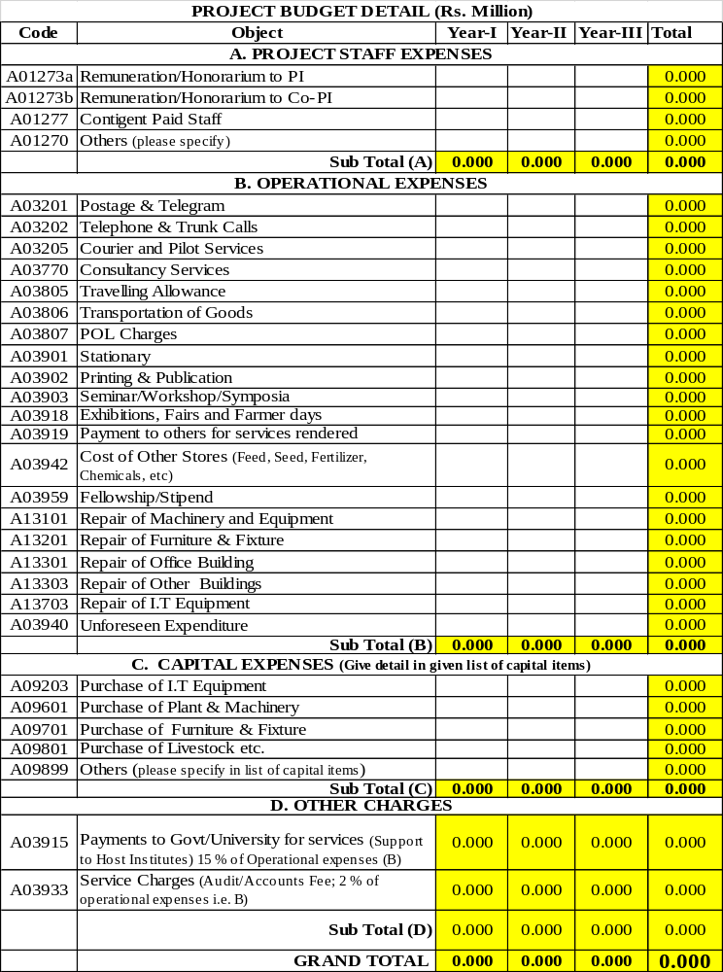

NB. Attach justification for all the capital expenses with estimated costs along with supporting invoice/catalogue pages)

LIST OF CAPITAL ITEMS*
(Insert more rows where needed)
Head | Item with Specifications | Rate | Quantity | Amount (Rs.)
A09203 | Purchase of I.T Equipment
Sub-total
A09601 | Purchase of Plant & Machinery
Sub-total
A09701 | Purchase of Furniture & Fixture
 | Sub-total
A09801 | Purchase of Livestock etc.
Sub-total
A09899 | Others (please specify)
Sub-total
GRAND TOTAL
*Give justification of capital items

Note:
- Please attach quotation for each item costing Rs. 0.100 million or more
- After the completion of project, the capital assets will be the property of EFS, UAF. However, the equipment, etc. might be allotted to participating/cooperating Institutions with fair justification.

15. State if the proposal has been submitted to some other aid giving agency for financial support, if so with what result?

16. Certification:
It is certified that the above information is accurate and the proposal will be executed in accordance with the agreement with EFS, UAF. That I will complete the proposed work plan and the results/ outcomes of the project will be shared with EFS, UAF.

Principal Investigator  Name: ______________________  ______________________ (Seal and Signature)  Date: ______________________ | Co-Principal Investigator  Name: _____________________  _____________________  (Seal and Signature)  Date: _____________________

17. Endorsement

It is certified that this proposal has the concurrence and support of

Chairman of Department  ______________________ (Seal and Signature)  Date: ______________________ | Dean/Director/Head  _____________________  (Seal and Signature)  Date: _____________________
Note:
- In case of faculty members from UAF, endorsement is required from the Chairman and Dean/Director concerned and the proposal must be routed through Director, ORIC.
- In case of applicants from outside the UAF, endorsement from the Head of Institution/organization is required in addition to the concerned Dean/Director/Chairman.

Literature Cited:

